**LP-1 SPOS LA2**

**Neeti Kurulkar**

**Design suitable data structures and implement Pass-I and Pass-II of a two-pass macroprocessor. The output of Pass-I (MNT, MDT and intermediate code file without any macro definitions) should be input for Pass-II.**

**Input Files:**

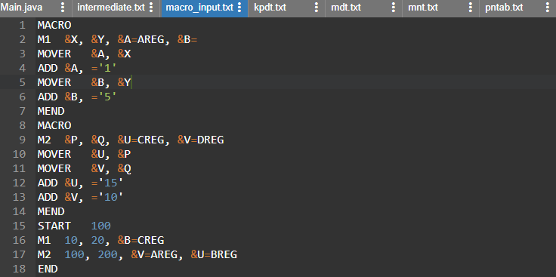

**Code:**

1. **Pass 1**

**import java.io.*;**

**import java.util.Iterator;**

**import java.util.LinkedHashMap;**

**public class Main {**

**public static void main(String[] args) throws IOException{**

**BufferedReader br=new BufferedReader(new FileReader("macro_input.txt"));**

**FileWriter mnt=new FileWriter("mnt.txt");**

**FileWriter mdt=new FileWriter("mdt.txt");**

**FileWriter kpdt=new FileWriter("kpdt.txt");**

**FileWriter pnt=new FileWriter("pntab.txt");**

**FileWriter ir=new FileWriter("intermediate.txt");**

**LinkedHashMap<String, Integer> pntab=new LinkedHashMap<>();**

**String line;**

**String Macroname = null;**

**int mdtp=1,kpdtp=0,paramNo=1,pp=0,kp=0,flag=0;**

**while((line=br.readLine())!=null)**

**{**

**String parts[]=line.split("\\s+");**

**if(parts[0].equalsIgnoreCase("MACRO"))**

**{**

**flag=1;**

**line=br.readLine();**

**parts=line.split("\\s+");**

**Macroname=parts[0];**

**if(parts.length<=1)**

**{**

**mnt.write(parts[0]+"\t"+pp+"\t"+kp+"\t"+mdtp+"\t"+(kp==0?kpdtp:(kpdtp+1))+"\n");**

**continue;**

**}**

**for(int i=1;i<parts.length;i++) //processing of parameters**

**{**

**parts[i]=parts[i].replaceAll("[&,]", "");**

**//System.out.println(parts[i]);**

**if(parts[i].contains("="))**

**{**

**++kp;**

**String keywordParam[]=parts[i].split("=");**

**pntab.put(keywordParam[0], paramNo++);**

**if(keywordParam.length==2)**

**{**

**kpdt.write(keywordParam[0]+"\t"+keywordParam[1]+"\n");**

**}**

**else**

**{**

**kpdt.write(keywordParam[0]+"\t-\n");**

**}**

**}**

**else**

**{**

**pntab.put(parts[i], paramNo++);**

**pp++;**

**}**

**}**

**mnt.write(parts[0]+"\t"+pp+"\t"+kp+"\t"+mdtp+"\t"+(kp==0?kpdtp:(kpdtp+1))+"\n");**

**kpdtp=kpdtp+kp;**

**//System.out.println("KP="+kp);**

**}**

**else if(parts[0].equalsIgnoreCase("MEND"))**

**{**

**mdt.write(line+"\n");**

**flag=kp=pp=0;**

**mdtp++;**

**paramNo=1;**

**pnt.write(Macroname+":\t");**

**Iterator<String> itr=pntab.keySet().iterator();**

**while(itr.hasNext())**

**{**

**pnt.write(itr.next()+"\t");**

**}**

**pnt.write("\n");**

**pntab.clear();**

**}**

**else if(flag==1)**

**{**

**for(int i=0;i<parts.length;i++)**

**{**

**if(parts[i].contains("&"))**

**{**

**parts[i]=parts[i].replaceAll("[&,]", "");**

**mdt.write("(P,"+pntab.get(parts[i])+")\t");**

**}**

**else**

**{**

**mdt.write(parts[i]+"\t");**

**}**

**}**

**mdt.write("\n");**

**mdtp++;**

**}**

**else**

**{**

**ir.write(line+"\n");**

**}**

**}**

**br.close();**

**mdt.close();**

**mnt.close();**

**ir.close();**

**pnt.close();**

**kpdt.close();**

**System.out.println("Macro Pass1 Processing done. :)");**

**}**

**}**

**Output of Pass1 and Input for Pass2:**

1. **intermediate.txt**

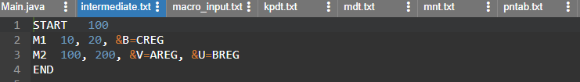

1. **kpdt.txt**

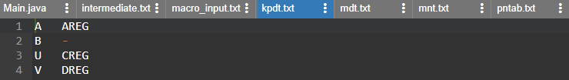

1. **mdt.txt**

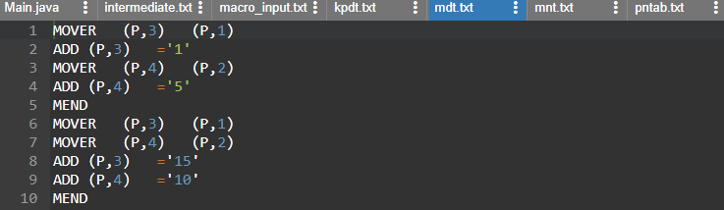

1. **mnt.txt**



1. **pntab.txt**



1. **Pass 2:**

**import java.io.*;**

**import java.util.HashMap;**

**import java.util.Vector;**

**class MNTEntry {**

**String name;**

**int pp,kp,mdtp,kpdtp;**

**public MNTEntry(String name, int pp, int kp, int mdtp, int kpdtp) {**

**super();**

**this.name = name;**

**this.pp = pp;**

**this.kp = kp;**

**this.mdtp = mdtp;**

**this.kpdtp = kpdtp;**

**}**

**public String getName() {**

**return name;**

**}**

**public void setName(String name) {**

**this.name = name;**

**}**

**public int getPp() {**

**return pp;**

**}**

**public void setPp(int pp) {**

**this.pp = pp;**

**}**

**public int getKp() {**

**return kp;**

**}**

**public void setKp(int kp) {**

**this.kp = kp;**

**}**

**public int getMdtp() {**

**return mdtp;**

**}**

**public void setMdtp(int mdtp) {**

**this.mdtp = mdtp;**

**}**

**public int getKpdtp() {**

**return kpdtp;**

**}**

**public void setKpdtp(int kpdtp) {**

**this.kpdtp = kpdtp;**

**}**

**}**

**public class Main {**

**public static void main(String[] args) throws Exception {**

**BufferedReader irb=new BufferedReader(new FileReader("intermediate.txt"));**

**BufferedReader mdtb=new BufferedReader(new FileReader("mdt.txt"));**

**BufferedReader kpdtb=new BufferedReader(new FileReader("kpdt.txt"));**

**BufferedReader mntb=new BufferedReader(new FileReader("mnt.txt"));**

**FileWriter fr=new FileWriter("pass2.txt");**

**HashMap<String, MNTEntry> mnt=new HashMap<>();**

**HashMap<Integer, String> aptab=new HashMap<>();**

**HashMap<String,Integer> aptabInverse=new HashMap<>();**

**Vector<String>mdt=new Vector<String>();**

**Vector<String>kpdt=new Vector<String>();**

**int pp,kp,mdtp,kpdtp,paramNo;**

**String line;**

**while((line=mdtb.readLine())!=null)**

**{**

**mdt.addElement(line);**

**}**

**while((line=kpdtb.readLine())!=null)**

**{**

**kpdt.addElement(line);**

**}**

**while((line=mntb.readLine())!=null)**

**{**

**String parts[]=line.split("\\s+");**

**mnt.put(parts[0], new MNTEntry(parts[0], Integer.parseInt(parts[1]), Integer.parseInt(parts[2]), Integer.parseInt(parts[3]), Integer.parseInt(parts[4])));**

**}**

**while((line=irb.readLine())!=null)**

**{**

**String []parts=line.split("\\s+");**

**if(mnt.containsKey(parts[0]))**

**{**

**pp=mnt.get(parts[0]).getPp();**

**kp=mnt.get(parts[0]).getKp();**

**kpdtp=mnt.get(parts[0]).getKpdtp();**

**mdtp=mnt.get(parts[0]).getMdtp();**

**paramNo=1;**

**for(int i=0;i<pp;i++)**

**{**

**parts[paramNo]=parts[paramNo].replace(",", "");**

**aptab.put(paramNo, parts[paramNo]);**

**aptabInverse.put(parts[paramNo], paramNo);**

**paramNo++;**

**}**

**int j=kpdtp-1;**

**for(int i=0;i<kp;i++)**

**{**

**String temp[]=kpdt.get(j).split("\t");**

**aptab.put(paramNo,temp[1]);**

**aptabInverse.put(temp[0],paramNo);**

**j++;**

**paramNo++;**

**}**

**for(int i=pp+1;i<parts.length;i++)**

**{**

**parts[i]=parts[i].replace(",", "");**

**String splits[]=parts[i].split("=");**

**String name=splits[0].replaceAll("&", "");**

**aptab.put(aptabInverse.get(name),splits[1]);**

**}**

**int i=mdtp-1;**

**while(!mdt.get(i).equalsIgnoreCase("MEND"))**

**{**

**String splits[]=mdt.get(i).split("\\s+");**

**//fr.write("+");**

**for(int k=0;k<splits.length;k++)**

**{**

**if(splits[k].contains("(P,"))**

**{**

**splits[k]=splits[k].replaceAll("[^0-9]", "");**

**String value=aptab.get(Integer.parseInt(splits[k]));**

**fr.write(value+"\t");**

**}**

**else**

**{**

**fr.write(splits[k]+"\t");**

**}**

**}**

**fr.write("\n");**

**i++;**

**}**

**aptab.clear();**

**aptabInverse.clear();**

**}**

**else**

**{**

**fr.write(line+"\n");**

**}**

**}**

**fr.close();**

**mntb.close();**

**mdtb.close();**

**kpdtb.close();**

**irb.close();**

**}**

**}**

**Output:**

